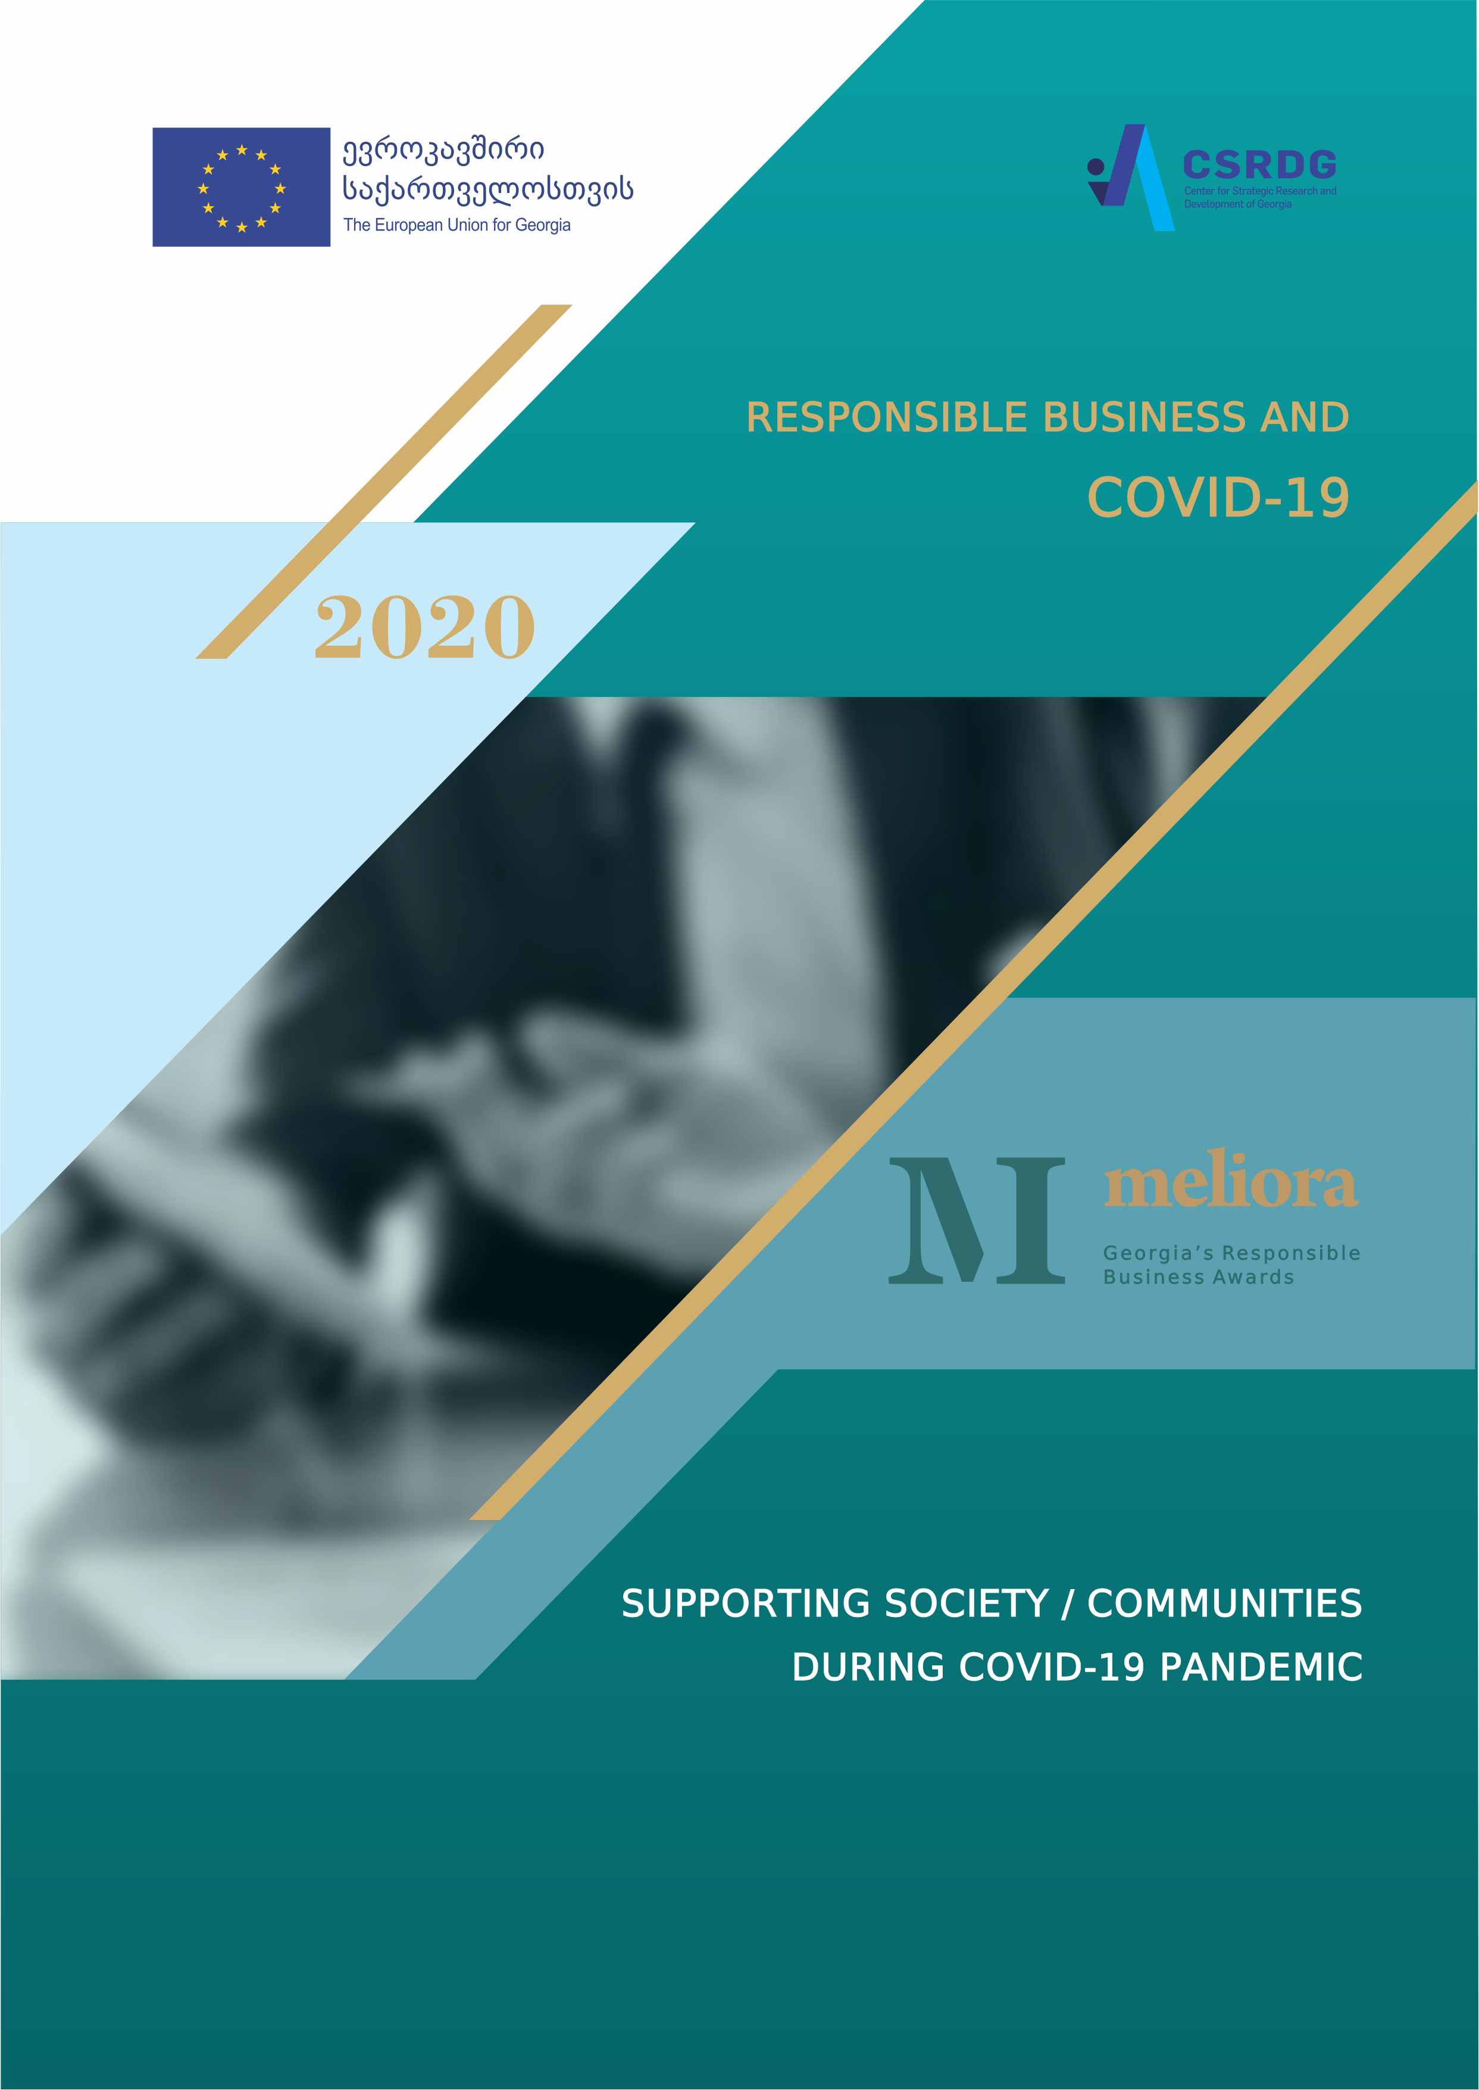

Award for Supporting Society and the Local Communities during the Covid 19 pandemic
What should the nomination be about: This category recognizes remarkable project/initiative/activities, which company implemented in response to Covid 19 crisis over and above statutory obligations imposed by regulators, aimed at supporting specific communities and society at large; initiatives might comprise providing humanitarian aid to most vulnerable communities and groups in need, socially disadvantaged individuals or those who found themselves without means of existence, caring about physical, mental and financial health and wellbeing of communities, transforming business solutions to adjust them to the new reality, supporting doctors and healthcare system etc.
ENTRY FORM
Company Name
Nomination Title
enter the title of the project/initiative you nominate ...
If successful, we will use the company name and nomination title as written here on any award materials (contest catalogue, award, press releases), so please ensure you write your company name and nomination title in full how you would like it published.
Contact Details
Main contact person
This person will be the main point of contact for all correspondence, enquiries or updates concerning your submission
Full Name:
Position:
Telephone number:
Mobile number:
Email:

Secondary contact
Please let us know whom we can address concerning the entry in your absence
Full Name:
Position:
Telephone:
Mobile:
Email:
If your contact information changes after submitting an application, it is your responsibility to amend your details with Contest Organizers.
Section I
This section is not scored but provides assessors with a good understanding of the overall business of the company in a wider context and its impact on society. Application forms missing this information will not be accepted.
- Company Details
Date of foundation of the company
We are a subsidiary of a foreign /Global company | □ YES □ NO
If yes, indicate the name of the parent company and year of beginning of operations in Georgia
Company Address
Legal form
Full name and job title of company Chief Executive (or equivalent)
Number of employees (approximately)
* Employee is an individual who is in an employment relationship with the organization, according to national law or its application. Employees comprise full time and part time employees.
If the company operates in several countries, please indicate total number of employees and also number of employees in Georgia.
Annual turnover | □ Less than 1 million GEL  □ From 1 million up to 12 million GEL  □ From 12 million up to 60 million GEL  □ More than 60 million Gel
The primary brands, products, and services
Geographic coverage
Does your company have a statement of the company’s mission & values (please indicate URL if relevant) | □ Yes □ No  URL:
Does your company have a code of ethics? (please indicate URL if relevant) | □ Yes □ No  URL:
If in 2019-2020 your company published CSR report, or has a CSR section on a webpage, please indicate URLs
If your company is part of the multinational company – please present the URL of the global sustainability/CSR report (if any)
Who is responsible for coordination of CSR activities in the organization - there is a CSR coordinator; CSR activities are coordinated by PR manager/Marketing manager/HR manager, other (please specify)
Please indicate, if your company is a member of any local or international network aimed at CSR promotion, e.g. Global Compact, CSR Club, AmCham CSR Committee, Georgian Pro Bono Network etc. (please list all)
Company webpage
Official Facebook/LinkedIn page
Twitter handle (if any) | @
Company logo: please submit a high-resolution version of company’s business logo (png or vector image) – upload logo on the google drive and share the link here:
Fill in the box:

- Impact of the Covid 19 pandemic on operations, supply and workforce
Describe, how Covid 19 pandemic impacted your business, what was the damage your business suffered, in particular:
Have you suspended operations due to the pandemic? If so, what percentage?
Do you have shortages of supply of products or services?
How has the pandemic affected your workforce? Did you have to dismiss your employees or put them on temporary leave? If so, what percentage?
What changes you had to introduce to your business due to Covid 19 crisis?
Quotation of the CEO or equivalent
Please provide a quote from your CEO (or equivalent) why responsible business is important for the nominated company and for him/her personally.
This point is not obligatory; however, it is very much appreciated to help assessors understand the support provided from the top of the organization. If submitted, quotation could be published in various award materials (such as web-page, information brochures etc.)
Fill in the box:
Name and position of the executive who is quoted:

Text of the quotation (max. 60 words):

N.B make sure you get in your request for this early on in the process to accommodate your CEO’s (or equivalent) diary/ sign off process.

Photo depicting the project activities (obligatory)
Please submit at least one high-resolution photo depicting the project-related activity (png or vector image). The photo will be published in the Contest Catalogue along with the summary of the submitted project – upload the photo on the google drive and share the link here:
Fill in the box:

End of non-scored section.
Section II: Description of the project or initiative you are nominating
This is a scored section. In this section you have to describe a project/ initiative in the selected area which you have implemented in 2020 in response to Covid 19 crisis and which you wish to nominate for the Award.
Please, describe in sufficient detail for Jury to understand and evaluate what did you do and why you did it, how it was successful and what it has changed for the better, what’s distinctive in this project, why it is unique and why it deserves the Award.
General Information:
Project status
□Ongoing
□Completed

When did the project/initiative start and what was the duration?
Start date: ____________________________________________________________________________
For the completed projects indicate date of completion: _______________________________________
a) Summary (max. 200 words)
Be sure to briefly reflect all important aspects of your nominated program/project/initiative in the Summary. In particular, briefly describe: a) main objective of the nominated project (problem, which project aimed to solve); b) what has been done by the project to achieve this objective/solve the problem; c) what were the results of the project; d) if project was implemented in partnership with some other organization, please mention. This statement should be written with the expectation that it will be published on the Contest’s website and in the communication materials.

Fill in the box:

b) Description of the nominated program/project/initiative
Please cover the following aspects of your project, as these will form the basis of assessment by the Jury:

1. Planning (300 words max. Weight - 20% of total score)
Please describe, what specific problem(s)/need(s) did you want to address with this initiative/project? How did you identify this problem(s)/needs? Did you consult other stakeholders in identifying the problem? (e.g. civil society organizations, other companies, public officials, community representatives etc.) – describe; When did you start designing/planning this initiative/project? Explain, why did you select this particular solution/strategy? If you consider your approach as innovative, it applies novel solutions to the problems, please describe and substantiate. Describe, what was involvement of top management/company leadership in the process?
In the case of international corporations, please specify - is the selected project part of the strategy of the headquarters abroad? What specific contribution was added by the Georgian branch?

Fill in the box:
Assessed: Relevance of the problem; efficient and innovative strategy/solution selected.

2. Implementation (500 words max. Weight - 30% of total score)
Describe the main activities of the nominated program/project/initiative: When did you start actually implementing initiative/project? How long the initiative was going on? Describe the main activities under the nominated initiative/project; If you had partners in this project, describe briefly, who were these partners, what was their role? If you involved your employees, or other stakeholders (e.g. civil society organizations, community representatives etc.) in implementation of the initiative, describe how? What resources did you invest in the project? (please list and quantify wherever possible); How was the initiative set up and managed? Did you face any specific challenges which put at risk implementation and how did you overcome them?
Fill in the box:
Assessed: Activities implemented and effective management of the project; Joint effort and participatory approach; Quick response to Covid-19 crisis and continuity of the initiative.
3. Results (500 words max. Weight - 20% of total score)
Describe what results you have achieved? What kind of assistance did project provided? How many beneficiaries did project have? How the nominated project has contributed to addressing the target problem? Please try to quantify, wherever possible and applicable, the benefits the project provides, indicate numbers, present evidence where possible. This is a key opportunity to put forward the strength of your entry.
Fill in the box:
Assessed: Achieved results and real change
Section III - Overall approach to community support, policies and performance
(500 words max. Weight – 10% of total score)
Describe overall policy and approach of company related to community support. Which topics and or target groups do you focus on and why? List and briefly describe other initiatives you have implemented in 2019-2020 (before and beyond covid 19) aimed at supporting and developing communities, which your company has implemented in 2019-2020 (if any). Quantitatively summarize, where feasible. You can refer to policy documents, codes of conduct, purpose and value statements, non-financial reports, and other documents demonstrating your responsible business approach, where feasible. Try to demonstrate your vision for the future and your approach to date. Members of the Jury want to see responsible business integrated in your core business strategy and culture.
Fill in the box:
Assessed: Existence of the consistent responsible policy and practices related to community support (beyond and before Covid 19 pandemic); efficient management systems and results achieved.
Section IV – Overall response to Covid 19 crisis
(500 words max. Weight - 20% of total score)
Describe how company has responded to Covid-19 crisis: a) Did you move your employees to online working mode? What % of your employees were moved online? When did you move your employees online (Indicate the date)? How many employees did you retain (indicate the number and % of the total staff)? How many employees you had dismiss or put on payless temporary leave? (indicate the number and % of the total staff)? How many employees have been receiving reduced salary? How many employees did you return back to full employment? What did you do to support your employees and ensure their physical health, social and mental wellbeing during Covid 19? - describe. If you had to dismiss your employees, did you do something to help them to earn means of existence?
b) what else have you done, apart from the nominated project? what other initiatives/activities have company implemented in relation to customers, suppliers, partners and/ or society? Describe how did you transform your business after the lockdown to minimize health risks (beyond official requirements), ensure business continuity and build back sustainably?
Please try to quantify, wherever possible and applicable, indicate numbers, present evidence of measurable results where possible.
Fill in the box:
Assessed: Immediate and complex response to covid 19 outbreak to support employees, customers, suppliers, partners and society.
Please note:
- You do not have to provide equally detailed answers to all above questions to submit an entry. Provide as much information as available.
- During the evaluation the scale of the activities and results will be assessed in relation to the size of the company.
- You are welcome to include in the above sections information about other factors which, in your opinion, may influence decision of the Jury.
- When completing your entry, please refer also to the Evaluation Scoring Guide, available at: www.meiora.ge
Section V: Links and evidence (optional)
This part is not obligatory, however submitting evidence and proofs for your project will help the Jury to properly asses your entry and increases the chances of winning. Please submit any materials about the project that you have (documents, photos, videos, url) to illustrate the content of your nomination and results achieved. All file types are accepted only as a soft copy.
When providing photos, please provide high resolution photos (in jpg, tif or png format); When providing the extensive documents, please indicate exact pages that you would like the Jury to pay attention to; You can also include relevant URL links to supporting evidence in the main text of the Entry, next to the point the evidence supports.
Please be as specific about page number of the submitted attachment or video timeframe as possible. Jury will not be able to read full extensive documents, so it is important to signpost the most relevant aspects of any evidence provided.

Please upload all your supporting materials on google drive, bound in a package/folder and share the link:
Fill in the box:

Final Statements
Confidentiality
Let us know here if you would like some aspects of your entry kept confidential
□ I do not want to keep any aspect of my entry confidential
□ Please keep confidential following parts of my entry ________________________________________

Mandatory requirements:
The company has not been legally convicted in the past three years in connection with its business activities.
The activities described in the nomination comply with the legislative requirements of Georgia.
Cases:
If the company has been linked with some scandals for the past three years (2018-2020), please describe it in no more than 300 words and comment the position of the company (Evaluators often have critical information about business cases from the media, and the Nominated Companies also have the opportunity to present their views so the Jury can judge the nomination objectively):
Fill in the box:
DECLARATION OF THE COMPANY
Please attach to your submission the scanned Declaration of the Company signed by Chief Executive (or equivalent), or person responsible for the nomination.
You can download the Sample of the Declaration here - https://meliora.ge/uploads/faqs/Declaration%20of%20a%20Company%20ENG%20-2020.docx

DECLARATION OF PARTNER
If you mention a significant partnership with a different organization in the nomination, please indicate:
Name of the partner organization _______________________________________________________________

You should also attach to your submission the scanned Declaration of the Partner signed by person representing the partner.

You can download the sample of the Partner’s Declaration here - https://meliora.ge/uploads/faqs/Declaration%20of%20a%20Partner%20ENG%20-%202020.docx

Please be sure to complete all sections. Incomplete applications would not be considered

Checklist
Before you submit your Entry, please make sure that:
- You have selected the Entry Form of the appropriate category
- All section of the Entry From are filled
- High resolution logo of your company (png or vector image) is uploaded on the google drive and the link is inserted in the appropriate place of the section I of the Entry form
- High resolution project-related photo for the contest catalogue (png or vector image) is uploaded on the google drive and the link is inserted in the appropriate place of the section I of the Entry form
- Documents and evidence supporting your application are uploaded on a google drive, bound in a package/folder and the link is inserted in the appropriate place of the section IV of the Entry Form
- Scanned Declaration of the Company, signed by CEO or person responsible for the application is attached to your Entry
- Scanned Declaration of a Partner (if you mention a significant partnership with a different organization in the nomination) signed by CEO or other authorized representative of the Partner organization is attached to your Entry.

How to apply
Send us a completed Entry form in PDF format along with the attachments to the following email: csrawards@meliora.ge no later than Monday, 7 December, 2020.
Please refer also to the Guidelines for the Applicants and Terms and Conditions for further supporting information.
If you do not receive a notification email within 3 business days confirming the receipt, please contact us on the following number: 599 690969 or via e-mail: csrawards@meliora.ge

